TSMaster What’s New

2025-12-02
[1] New: Panel PageControl now supports deleting single page
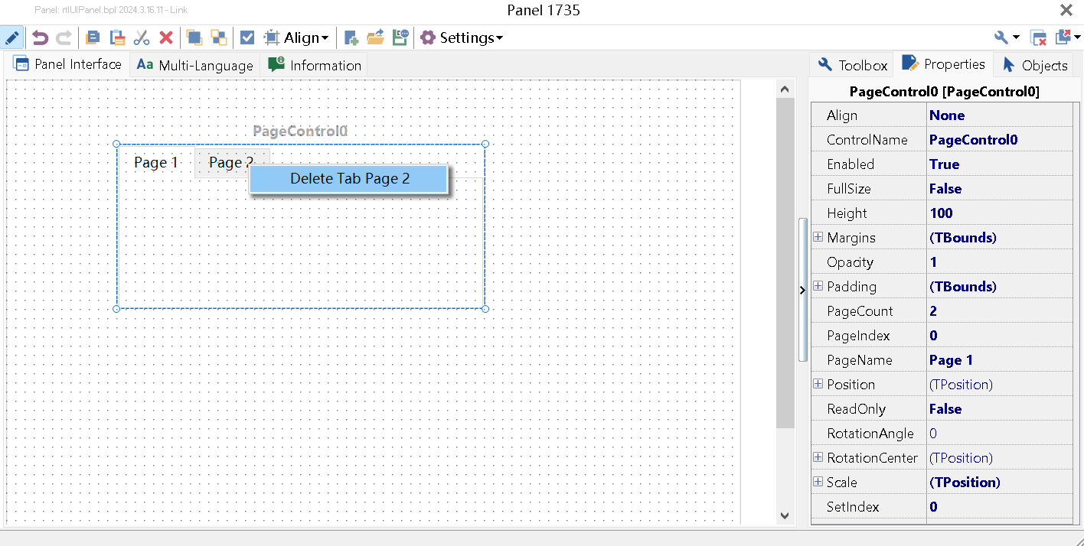
[2] New Option: Generate system var direct access option in mini program, activated by default
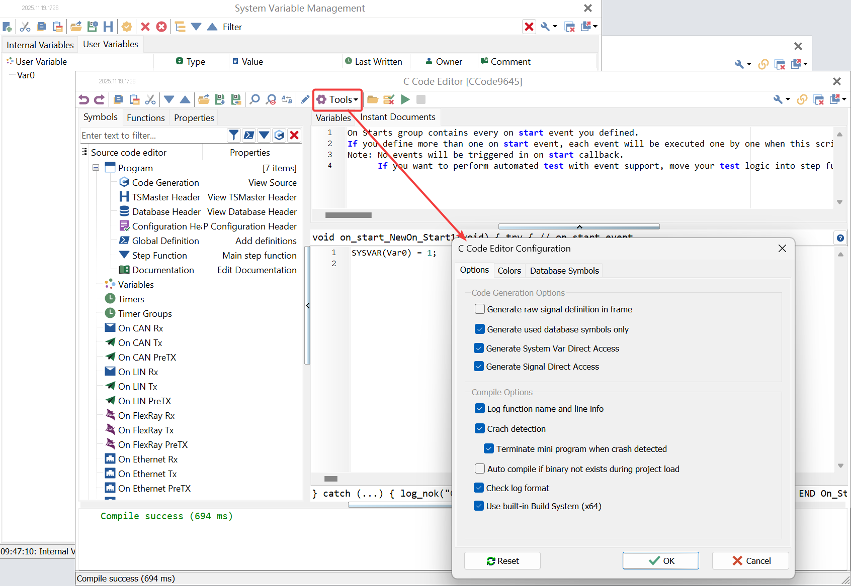
[3] New Mp and Dll Apis: get/set element of system var of array type
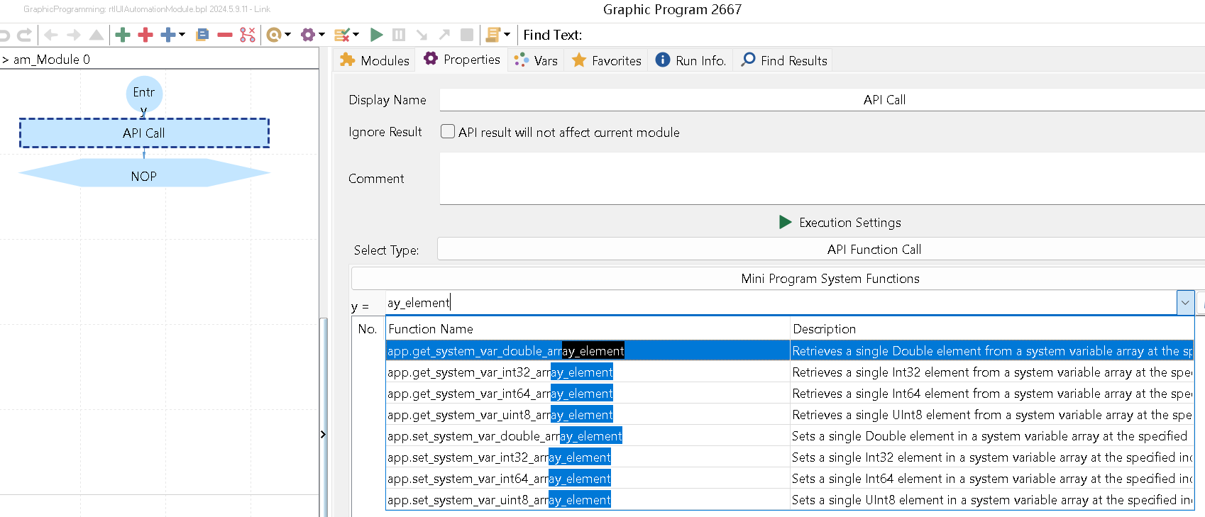
[4] New: Array typed system variable direct access supported in C Mini Program
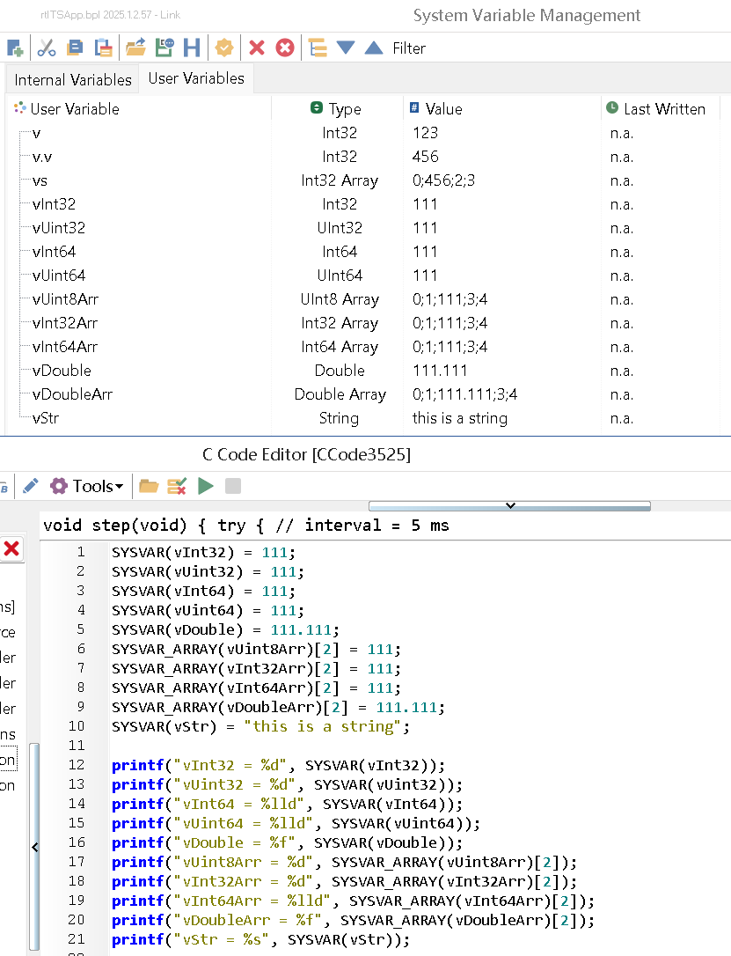
[5] New Mp and Dll APIs: generic RBS signal get/set functions
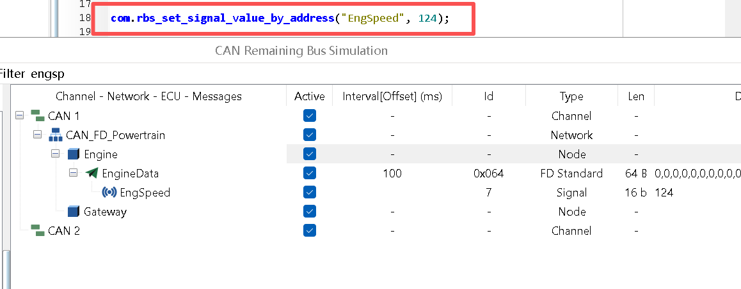
[6] New: Generic RBS Signal direct access supported in C Mini Program
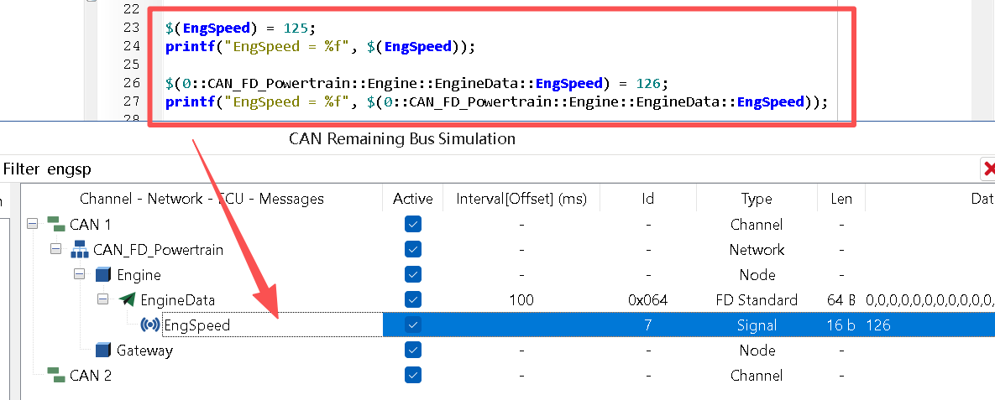
[7] New Option: Generate signal direct access option in mini program, activated by default
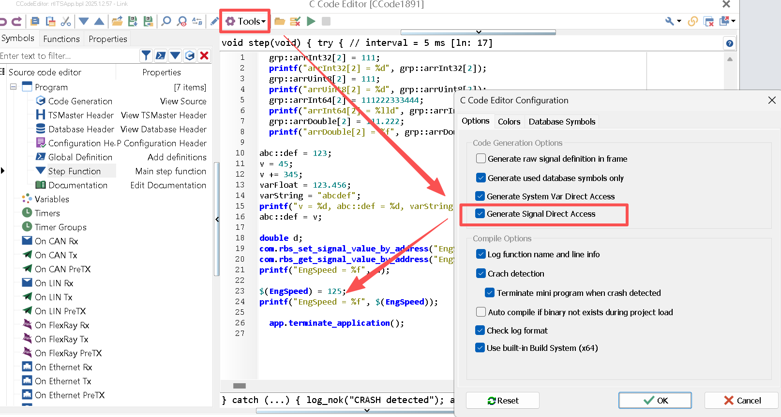
[8] New: Device TC1052 supported
[9] New: MP: Add API of metric frame intervals for CAN bus
- app.metric_start
- app.metric_stop
- app.metric_register_can_frame_interval
- app.metric_unregister_can_frame_interval
- app.metric_get_w_reset_can_frame_interval_stat
[10] New Mp and Dll Api to get system variable type
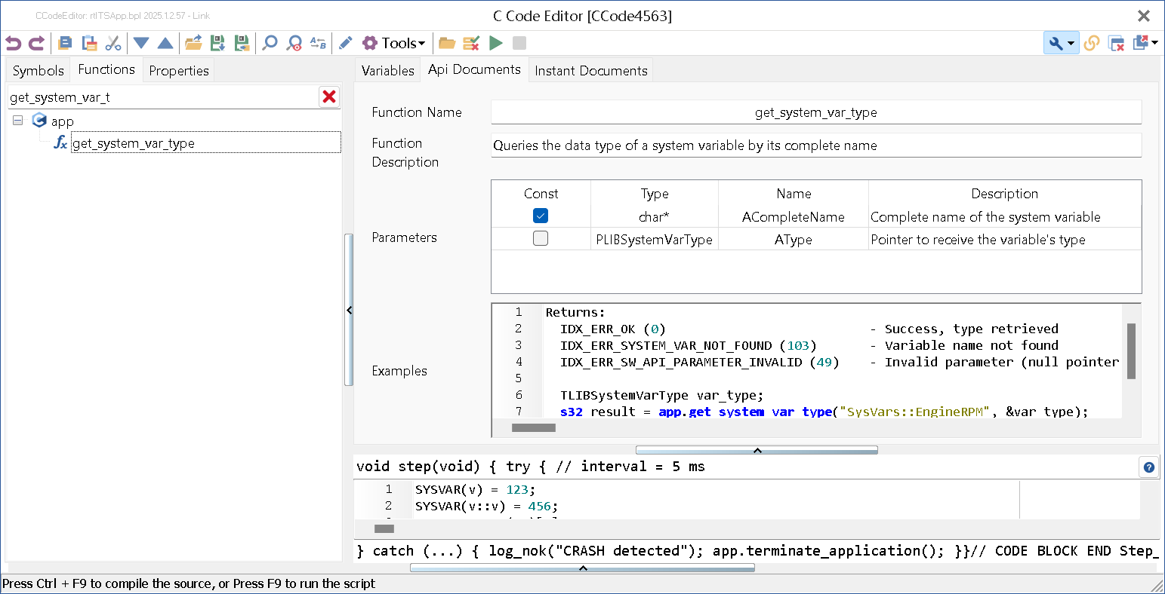
[11] New Mp and DLL Apis to call system and library function with serialized arguments
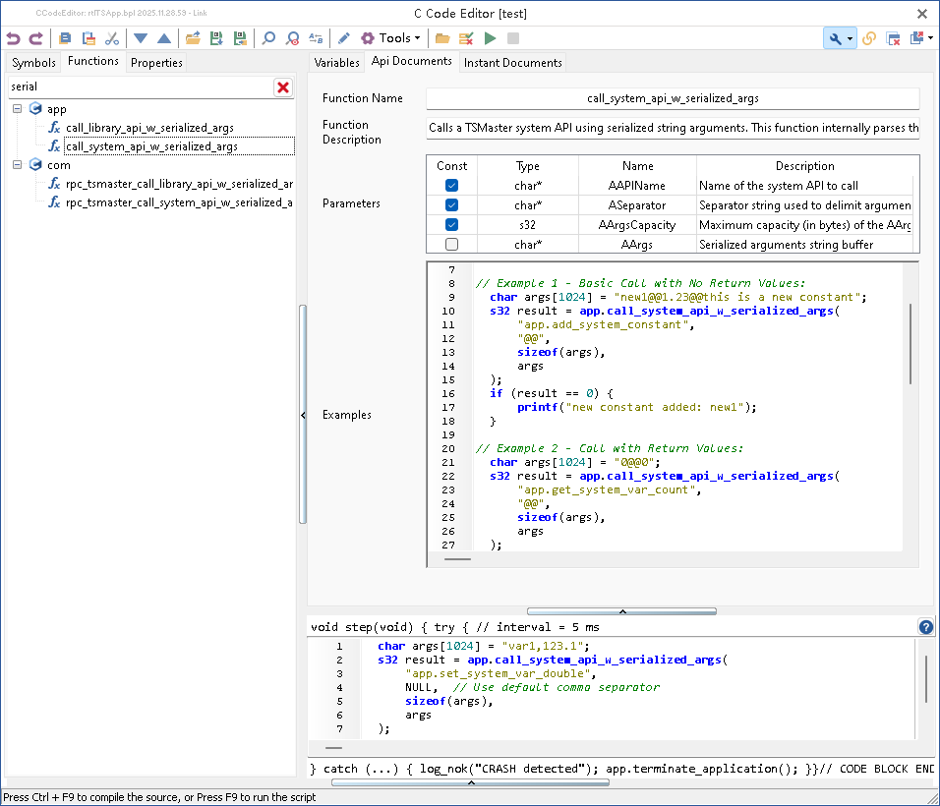
[12] Bug fixes until 2025-12-1

